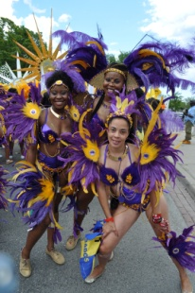

Carnival 2016
“Islands in D’ Sun”



CUPE Ontario, with the Racial Justice Committee, is teaming up with Carnival mas band Concept Costume Creators. This year's theme is “Islands in D’ Sun”. As part of our participation as CUPE Ontario members we seek to talk about the connection between Carnival and the labour movement, and to provide background about Carnival.

Carnival is a celebration of African-Caribbean culture and the diversity that makes our community such an exciting, vibrant place to live. But it is more than just a celebration.

Around the world, Carnival celebrations began as part of the struggle for emancipation. They were a way for enslaved Africans to assert their dignity and humanity in a society where they were prohibited from other forms of self-expression.

In Ontario, emancipation began with the Act Against Slavery in 1793. This holiday long weekend is dedicated to the memory of that act, which pre-dates the creation of Canada as a country.

In the 223 years since the Act was passed, racialized workers have won the right to vote, to own property, and to live and work anywhere in Canada.

But emancipation and equality are two very different things. While much progress has been made in terms of rights, the reality of equality is still a long way off.

Today, racialized workers with full-time jobs earn, on average, about $10,000 a year less than white workers.
Unemployment for racialized workers is almost 40 per cent higher than for non-racialized workers. In the case of Canadians of African heritage it is 73 per cent higher.

Racialized workers are also far more likely to have to accept part-time and casual work with low wages and no benefits. These are some of the reasons why nearly 60 percent of poor families in Toronto, for example, are from racialized groups.

The challenges experienced by racialized workers are amplified by government austerity agendas that drive more privatization of public services, like Hydro One, and more cuts to public services. This is one reason why CUPE Ontario continues to fight to Keep Hydro Public.

While we celebrate emancipation and the progress Canada has made, we must also continue to demonstrate against the racism that keeps equality from becoming a reality. Unions play an important role in the fight for equality and decent working conditions.

This Carnival, we look back at our history of oppression, of struggle and of emancipation, and we look forward to continuing the struggle together.

Visit cupe.on.ca to learn more about what CUPE Ontario is doing to improve the lives of workers in communities across the province.

COPE343

