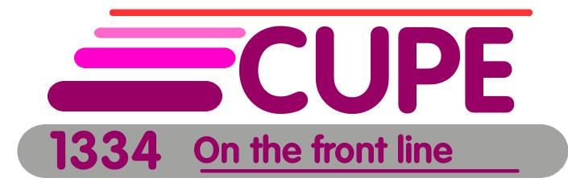

Mental Health Survey

- The University has struck a Wellness in the Workplace committee to look at the wellness of workers both physically and mentally.

- As part of this initiative they will be circulating a survey.

- It is our opinion that this program focuses on the stress that already exists in worker’s lives and only superficially looks at psychological hazards in the workplace

- Their survey will be used to develop programming around health e.g. yoga, weight management, financial coaching etc.

- We believe that we need to uncover psychological hazards in the workplace so we can push to change the work not the worker

- CUPE and OSSTF have partnered with OHCOW – the occupational health centre for Ontario workers – and are circulating a different survey

- The survey was developed in Copenhagen and is used worldwide. It is free and is part of a global movement to identify psychological hazards in the workplace

- It asks questions about job satisfaction, bullying , harassment, safety, working alone, supervisor performance etc. and gives a clear picture of your experience in the workplace

- The survey is confidential and the information will not be seen by the Union or university. The surveys will go directly to OHCOW in a sealed envelope within a sealed box.

- We have hard copies for those who want them. There is also an online version that can be found at

https://www.surveymonkey.com/r/OSSTF_CUPE_stress_survey

- We are hoping to have all surveys completed by Oct 16

- The drop off box will be set up in the Union office at the following times:

Day shift - Oct 11, 12 and 13 from 9 am to 430pm
Night Shift - Wednesday (11th), Thursday (12th) and Sunday (15th) from 1030 to 1130 pm and again at the end of shift 6 to 7am
Room 347 in the University Centre
- This is not an either/or exercise and we do not discourage you from filling out both the university survey and our survey. However, if you are only going to do one we highly recommend you fill out the one we are presenting today

- We focus on eliminating physical hazards in the workplace lets now eliminate the psychological ones

- CHANGE THE WORK NOT THE WORKER!

