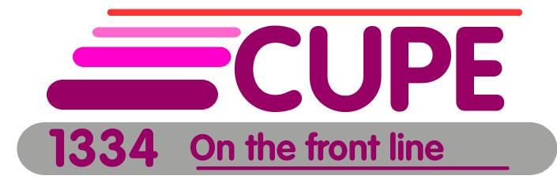
WHO’S WHO

Position | Name | Cell | Social Media
President | Janice Folk-Dawson | 519 766 8376 | @cupejfd - Twitter  folkdawson@gmail.com
1st Vice President | Laura Maclure | 519 400 4655 | @LauraMaclure - Twitter  maclurelaura@gmail.com
2nd Vice President | Darrin Chasty | 519 803 4211 | dchasty@gmail.com
Treasurer | Brian Gorman | 519 400 4755 | Facebook - Brian Gorman  gorman_b@hotmail.com
Recording Secretary | Lynda French | 519 400 6052 | Facebook - Lynda French
Chief Steward | Nick Gielen | 519 400 7767 | ngielen@uoguelph.ca
Deputy Chief Days | Scott Reynolds | 519 993 6325
Deputy Chief Nights |  | 519 400 8055
Sgt at Arms | Scott McWhinne

Stewards | Email | Cell
Candice Welch | candice.welch@hotmail.com | 647 802 6232 | Facebook -Candice Welch
Dan Brown
Dave Cuzen

Union Office University Centre 519 824 4120 ext. 58536
Office Outside Line (answering machine) 519 836 5470
Fax Machine 519 763 0810
Union email cupe1334@uoguelph.ca
Facebook CUPE 1334
Twitter @CUPE1334
Website 1334.cupe.ca

